Smart Cattle Management

"Rising global population and standards of living are increasing the pressure on food-animal production, which leads to an increased requirement to manage animal productivity, health and well-being effectively," says Chris Dodge, IT director at General Alert. Furthermore, peoples’ awareness of a good food quality is getting more and more important and consequently farmers have to care about that in order to battle against other competitors. So does the owner of the ranch “Ponderosa”.

In this document, the smart solution powered by FIWARE should be described in order to monitor the health of the cows and to show evidences that the cattle living in the ranch enjoy a much better life compared to other ranches.

# Overview of the proposed solution

For the purpose of supervising the physical health of the cattle, there exist several different devices focused on different aspects, that can be combined.

The traditional method used to identify sick cattle is visual observation. With certain RFID ear tags this human observation tasks can be removed and even a bigger amount of more reliable and exact data is provided. The sensors in each ear tag constantly monitor livestock temperature, movement and other vital signs.

As this system’s range is not very big and it only gives information about whether the cattle move or not, but not about its exact position, this ear tag can be combined a special collar. This provides data about the cattle’s certain position, the cattle’s pregnancy, its illness, the bull’s efficiency, the Calves’ delivery and the calves’ conditions. So, if a cow is ill and moves strangely, for example away from the herd, this can be detected earlier and further actions can be initiated punctually.

In order to get more sophisticated information about the physical healthiness of the cattle, there exist a special sensor, that has to be swallowed by the cattle once and then stays in the inside of the cow. Besides others, it measures the cow’s temperature, breathing, heart and rumination rate. Assuming a cow has a rumination illness, the above-mentioned ear tag or cattle collar won’t detect any anomalies until the cattle’s temperature increases. This late detection might often be too late to save the cow.

Finally, from the quantity and quality of the milk and its ingredients, it can be inferred very exactly if the cattle are ill. As cattle are usually milked by automatic milking systems nowadays, including a special milk sensor helps to get information about the wellbeing of the cow in advance.

Regarding the desired evidences that cattle of this ranch enjoy a much better life compared to others, the mentioned milk sensor can help as well, because a happier and healthier cow produces milk of higher qualities, e.g. containing more vitamins.

Furthermore, the quality of the grazing area affects the quality of the cows’ life significantly. Therefor properties like the air, soil and pasture quality, temperature and humidity play an important role and can be monitored by using certain sensors set up in the grazing area.

As you can see, these sensors contain different kinds of technology and collect a huge amount of data. This data has to be combined and processed in order to inform or alert the farmer and other persons, like for example the veterinarian, via smartphone and computer applications and notifications. Consequently, a certain architecture including different communication interfaces is needed in order to accomplish these tasks.

# High-level software architecture description, including the communication interfaces between the different elements

The following architecture diagram gives an overview of the proposed solution and can be divided into four main parts. First, there are the IoT Devices, whose general functionality have been described in the previous chapter. There will be some additional information about each device in the following chapters. Some IoT Devices don’t directly push the obtained data to the IoT Agent, so a special reader/collector is needed. This can be seen in the architecture containing several RFID Eartags and RFID Readers as well.

Furthermore, there exist several different IoT Agents, that manage the communication with the mentioned IoT Devices.

All the collected data will be handed over to the Context Broker, which is the central part of the architecture. In order to store this data for statistical and long-term analysis of the obtained data, Cygnus and a Data Analyser in Hadoop is used.

Finally, there are three different types of User Applications, that get the information of interest from the Context Broker. The Wirecloud Webpage helps the farmer to get an overview of all the different components and data to be processed. With the smartphone and computer applications the farmer can easily access whatever information he needs (current information of certain cows, long-term information, statistics etc.) and the farmer will be notified and alerted in case of emergency. In case of emergency the Stable Notifier helps to quickly detect the affected cattle.



# Context Information to be managed

## RFID Ear Tag

|  |  |
| --- | --- |
| Active Attributes | temperature, movement, volume |
| Lazy Attributes |  |
| Commands |  |
| Static Attributes | sensor ID, cow name, cow id, cow birthday, sensor production date, sensor installation date, cow id history list |

## Cattle Watch

|  |  |
| --- | --- |
| Active Attributes | movement behaviour, pregnancy, illness, bull efficiency, calves’ delivery, calves’ conditions, location, tracing, theft warning |
| Lazy Attributes |  |
| Commands | indicator lamp |
| Static Attributes | sensor ID, cow name, cow id, cow birthday, sensor production date, sensor installation date, cow id history list |

## Vital Herd

|  |  |
| --- | --- |
| Active Attributes | core temperature, heart rate, respiration rate, stomach contraction rate, pH (short and long term), volatile fatty acid (short and long term), lactic acid (short and long term) |
| Lazy Attributes |  |
| Commands |  |
| Static Attributes | sensor ID, cow name, cow id, cow birthday, sensor production date, sensor installation date, cow id history list |

## Milk Sensor

|  |  |
| --- | --- |
| Active Attributes | milk volume, milk solids, lactose, mastitis indication, air admission, plant wash |
| Lazy Attributes |  |
| Commands |  |
| Static Attributes | sensor ID, sensor production date, sensor installation date |

## Pasture Sensor

|  |  |
| --- | --- |
| Active Attributes | air ingredients, soil ingredients, water ingredients, humidity, temperature |
| Lazy Attributes |  |
| Commands |  |
| Static Attributes | sensor ID, sensor production date, sensor installation date, location, land name |

# User experience

All of this collected data will be very useful for the farmer, but first this data has to be organized in order to enable easy access and a clear representation for the farmer. Therefor a smartphone application and a Wirecloud Webpage exist. So, after the farmer wakes up in the morning, he won’t go directly to the stable, instead of that he can check his computer if there are any problems and anomalies with his cows.

Furthermore, it is possible to directly access the data of one single cow, for example if there have been problems with this cow in previous days. Consequently, he is able to directly handle the detected problems and does not have to check every cow and detect problems and anomalies on his own. This will save a lot of time and makes the farmer’s and cattle’s life more comfortable.

In addition, in case of emergency the smartphone app alerts the farmer and other involved persons, like the veterinarian, via SMS or a phone call. For instance, if a cow calves and there are any complications during the birth, the farmer and the veterinarian will be notified. If the farmer and the veterinarian enter the stable to look after the cow that has some trouble, special stable notifiers directly lead the persons to the affected cattle. As you can see, the problem is detected as early as possible and the cow and its calf can be saved, otherwise especially during night the problem won’t be detected at all or too late, so the cow and calf could possibly die.

Finally, a Hadoop application gives the farmer access to different statistics on the smartphone and computer apps regarding the cattle’s health and the quality management as well. Furthermore, this application helps the farmer to classify the cows in different groups, because an intelligent data analyser tool identifies similar behaviour patterns and health properties. So, he can access whatever data he needs easily and use it for evidence that his cattle enjoy a good life and therefore he can use this data to advertise his high-quality food.

# Suitable IoT devices

Most of the IoT devices needed for a smart cattle management already exist.

The Semtech LoRa RFID ear tag constantly monitors the livestock temperature, movement and other vital signs, relays this data to a RF receiver, which sends the data to the Context Broker for further processing.

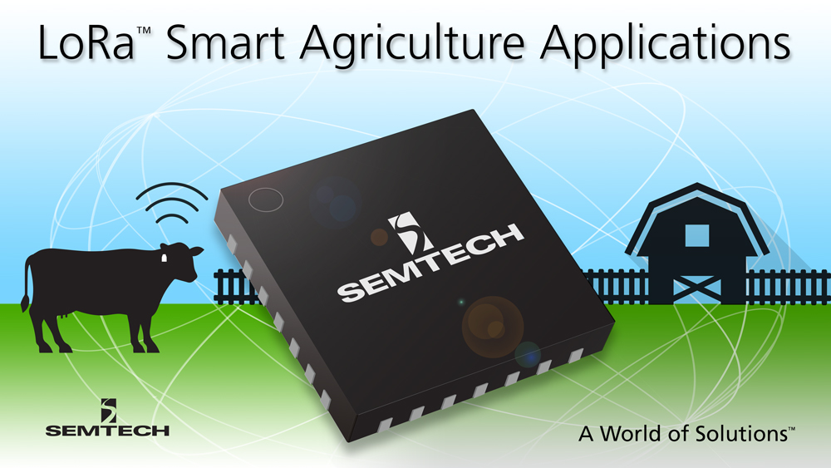

*Semtech LoRa RFID ear tag*

Furthermore, Cattle-watch, a special collar for cattle, collects data about behaviour information, pregnancy, illness, bull efficiency, calves’ delivery, calves’ conditions, location and illness early warning. This data can be sent for example via a GPRS system. The same company also offers other IoT devices like the before mentioned ear tags and pasture sensors, that measure air quality, soil quality, humidity and others. Consequently, the system is easily extendable and collects a lot of different data.

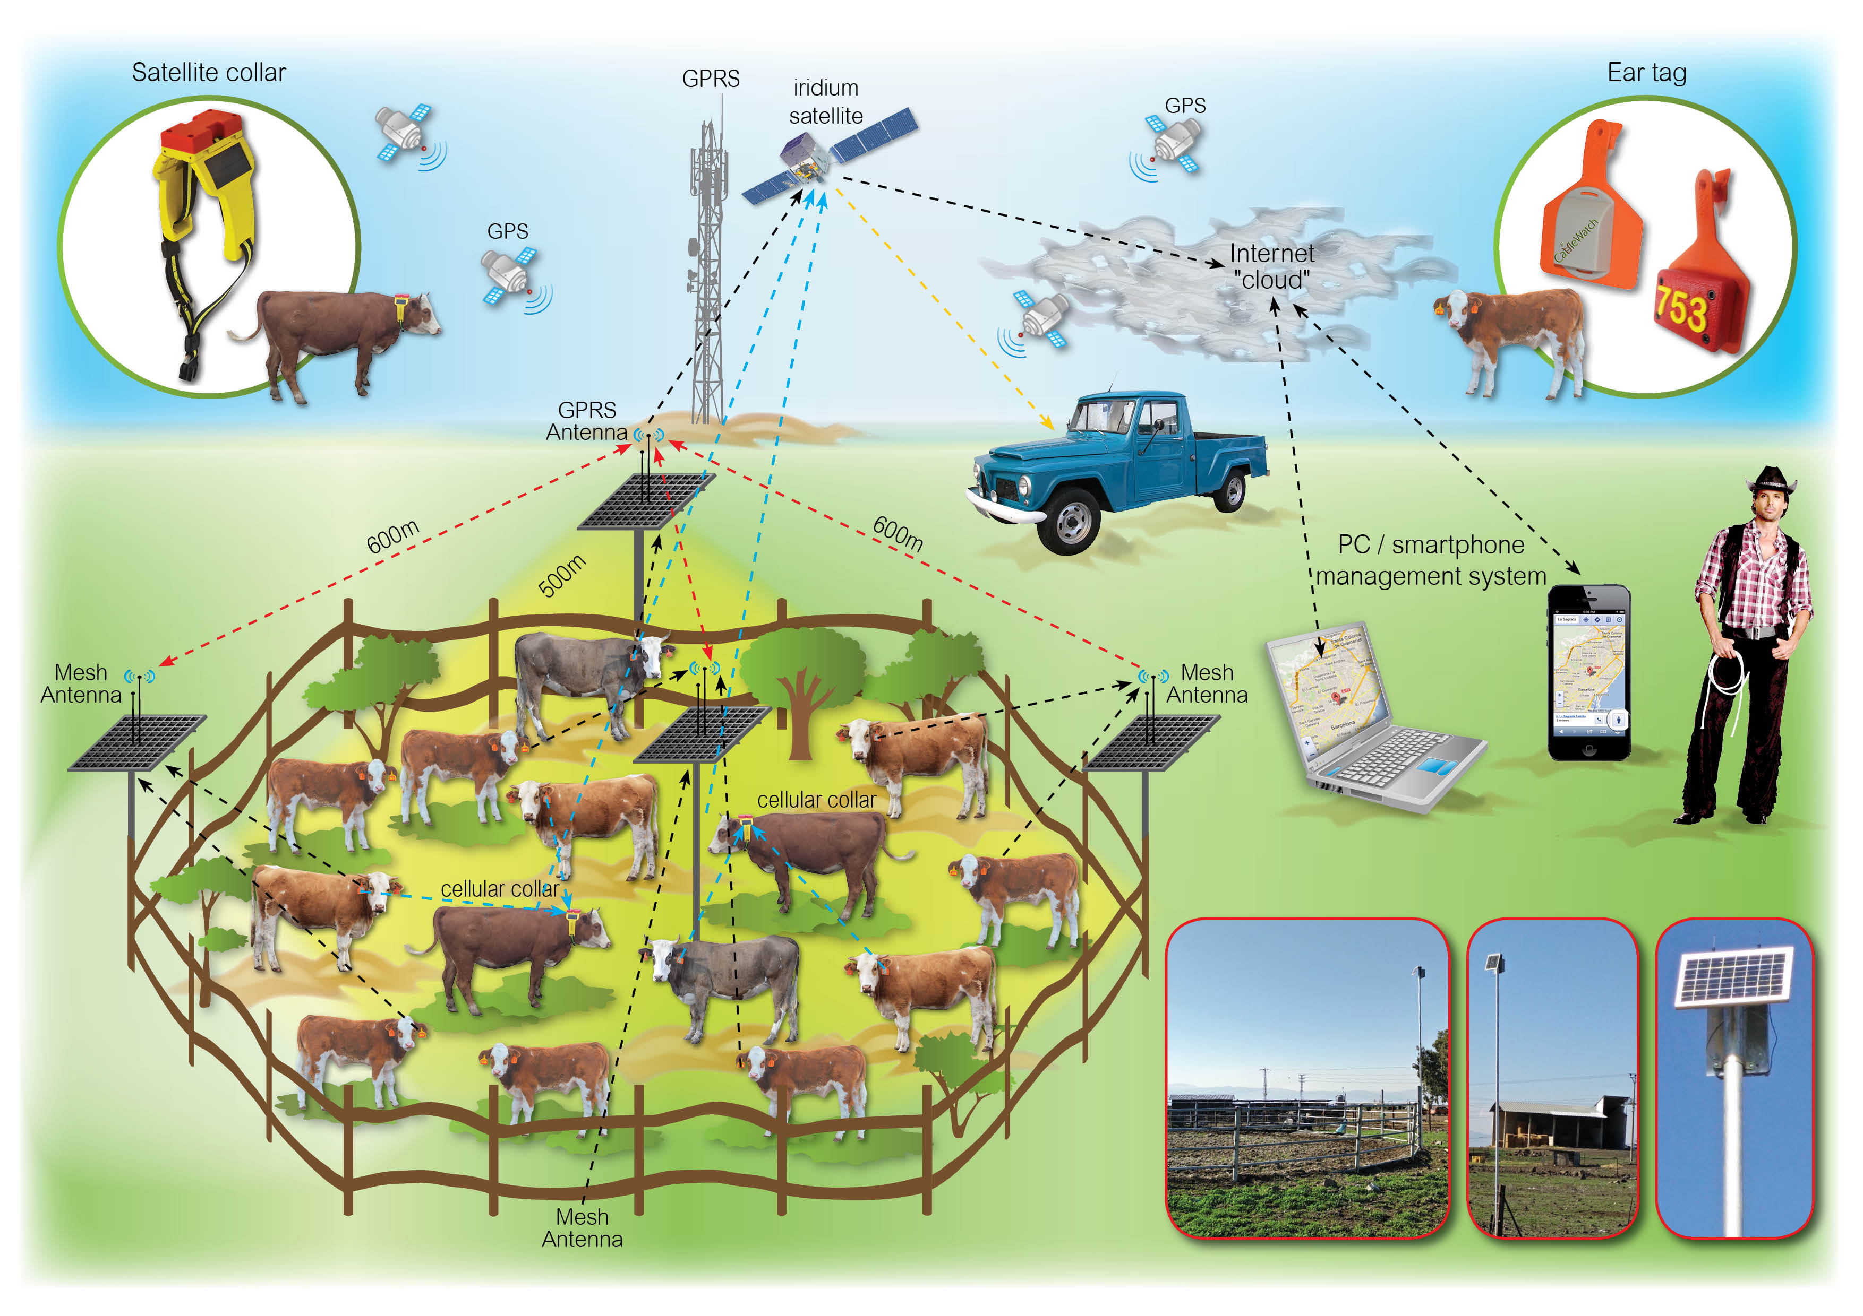

*GPRS System Architecture including Cattle-watch, ear tag and pasture sensor*

In addition to the quite superficial data, like the cow’s temperature, other types of sensors are needed in order to get more sophisticated data concerning the cow’s physical health. The Vital Herd solution measures core temperature, heart rate, respiration rate, stomach contraction rate, pH, volatile fatty acid and lactic acid for individual animal base-lining and a better, data-driven, individual animal management. It uses a wireless “epill” sensor, that has to be swallowed by the cow and stays in the stomach for the animal’s lifetime and forwards the collected information for further processing.

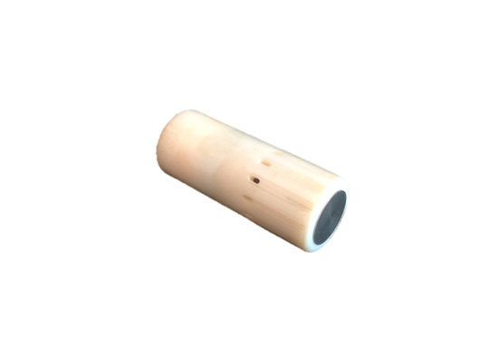

*Vital Herd “epill”*

Finally, the Saber milks sensor can be integrated in the milking machines in order to have a milk test every day automatically. This sensor monitors milk volume, milk solids, lactose and other properties and it helps to indicate mastitis as well.

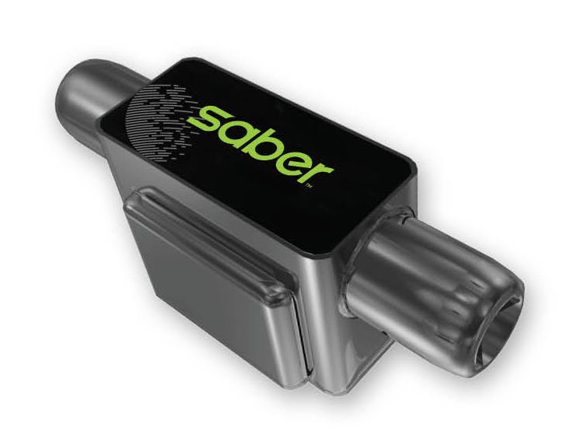

*Saber Milk sensor*

As you can see, there exist a lot of sensors that help to implement a smart cattle management. Some of these sensors collect similar data and usually come with their own applications. So, the Context Broker has to combine all the information given by the different sensors and it has to convey this information to the main applications in order to give a good overview over all the data.

# Potential application of BigData analysis techniques

A farmer’s everyday work does not only contain taking care about the cattle, a farmer also has to deal with a lot of paperwork. Documenting the illnesses, milk quality, pregnancies and parentage of every single cow are some examples for this. BigData analysis techniques, that access the relevant data and automatically process the information as desired, can significantly facilitate this task and the farmer’s work as well.

In addition, BigData analysis techniques can provide the farmer with useful additional information, that would be very hard and time-consuming to determine only by himself. For instance, BigData analysis techniques can collect the physical health data of every single cow given by the Vital Herd for example and compute some long term information like how a cow develops over time. This leads to several statistics, that help the farmer to get a good and accurate overview over certain cows, the whole herd and over the quality of the produced meat and milk as well.